**PF lab 8**

**8.1 Write a C++ program to add two integers. Make a function add() to add integers and display sum in main() function.**

**SOURCE CODE**

**#include<iostream>**

**using namespace std;**

**int main()**

**{**

**int a(int , int );**

**int b,c,result;**

**cout<<"Enter first number:"<<endl;**

**cin>>b;**

**cout<<"Enter second number:"<<endl;**

**cin>>c;**

**result=a(b,c);**

**cout<< b << "+" << c << "=" << result<<endl;**

**return 0;**

**}**

**int a(int a, int b)**

**{**

**int R;**

**R=a+b;**

**return(R);**

**}**

**OUTPUT**

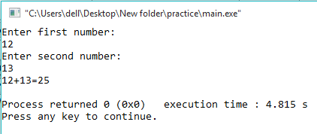

**8.2 Using functions write a program which takes the radius of a circle as input from the user, computes the area of the circle in function and display the area of the circle in the main body. Use data type: float.**

**SOURCE CODE**

**#include<iostream>**

**using namespace std;**

**int main()**

**{**

**float a;**

**float udf1(void);**

**a=udf1();**

**cout<<"Area of a circle is = " << a <<endl;**

**return 0;**

**}**

**float udf1(void)**

**{**

**float b,c;**

**cout<<"Enter the Radius:"<<endl;**

**cin>>b;**

**c=3.14*b*b;**

**return(c);**

**}**

**OUTPUT**

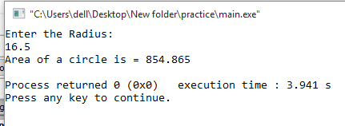

**8.3 Using functions, write a program which takes a character as an input and determines whether it is a vowel or consonant**

**SOURCE CODE**

**#include<iostream>**

**using namespace std;**

**int main()**

**{**

**char udf(void);**

**udf();**

**return 0;**

**}**

**char udf(void)**

**{**

**char a;**

**cout<<"Enter any ALPHABET:"<<endl;**

**cin>>a;**

**if ((a=='a') || (a=='e') || (a=='i') || (a=='o') || (a=='u')||(a=='A') || (a=='E') || (a=='I') || (a=='O') || (a=='U'))**

**{**

**cout<< a << ": is vowel letter!" <<endl;**

**}**

**else**

**{**

**cout<< a << ": is consonant " <<endl;**

**}**

**}**

**OUTPUT**

